|  |  |
| --- | --- |
| **cRI﷽﷽﷽﷽﷽﷽﷽﷽﷽﷽﷽﷽﷽﷽﷽﷽﷽﷽ticReports/**)尸一戈﷽﷽﷽﷽﷽﷽﷽﷽﷽s.1 operator.ehaveor behave Classification | Confidential |
| Doc Number | N/A |
| Date | July 17, 2013 |
| Version | V0.01 |

**Phoenix Multi Cable Mapping Checking SOP**

|  |  |
| --- | --- |
| Creator： | Lorky_Luo |
| Date： | 2013.07.17 |

**Revision History:**

|  |  |  |  |
| --- | --- | --- | --- |
| **Date** | **Version** | **Description** | **Modify by** |
| 2013/7/17 | V0.01 | New SOP Multi Cable Mapping Checking | Lorky_Luo |

1. **Glance**
   1. This document is used to checking the cable is mapping or not for multi test setup.
   2. The checking is based on the fixture cable setting. Please modify the cable names before testing
2. **Software**
   1. About Cable Mapping

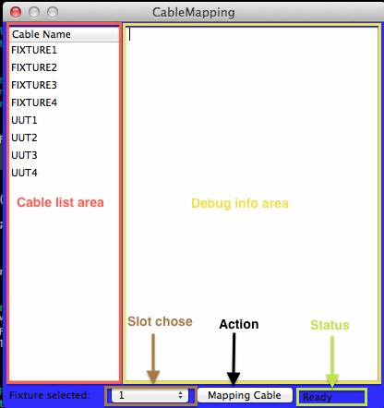

* 1. If the app can’t find any cables were connected with the computer, app can’t be opened.

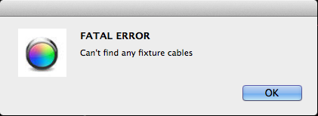

* 1. We can base on the fixture cable name to switch which fixture we want to checking

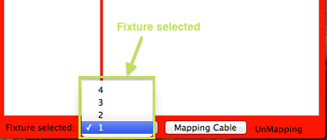

* 1. When we click the action button, it will remind you to put one unit into fixture

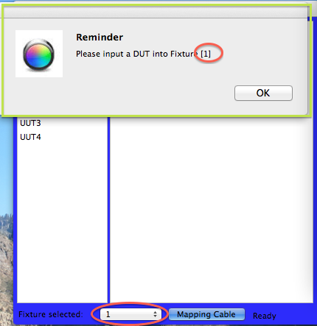

* 1. Test Pass, the status will change to “Mapping”, window’s background will be green and it will shown as below

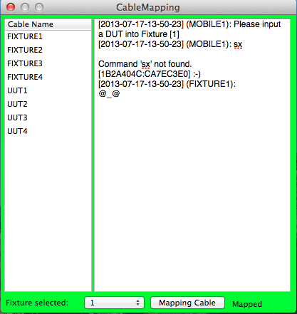

* 1. Test Fail, the status will change to “UnMapping”, window’s background will be red and it will shown as below

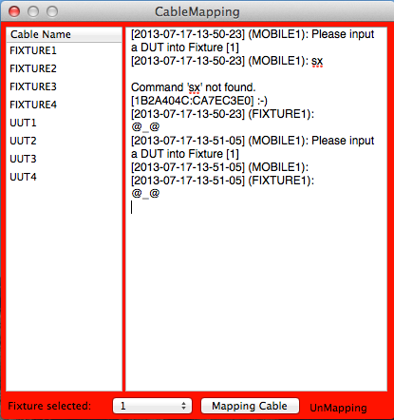

1. **Maintains** 
   1. Found out the setting file for this application. It’s in the app’s contains. Click right button and choose “Show Package Contents”

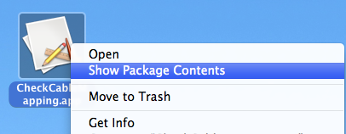

* 1. The setting file is at the path: “%PATH%/Contents/Resources/CableMapping.plist”, which %PATH% is means which URL you put the app to.

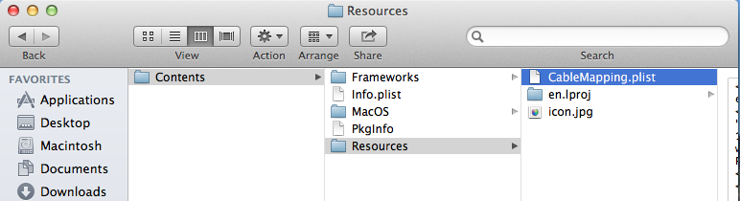

* 1. Open “CableMapping.plist” by “Property List Editor”, it should be shown as below.

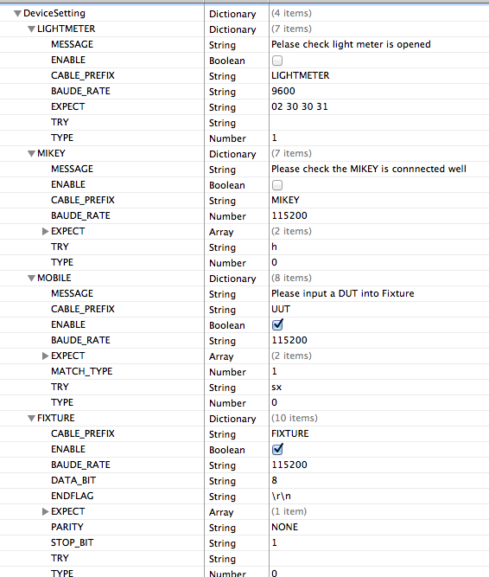

* 1. Parametric define
     1. ENABLE: Need to test this target or not.
     2. MESSAGE: A reminder message to reminder testor to do it first.
     3. CABLE_PREFIX: the cable name should contains this string
     4. BAUDE_RATE: baud rate for communication
     5. STOP_BIT: stop bit for communication
     6. ENDFLAG: end flag for communication
     7. PARITY: parity for communication
     8. TRY: use this string to try to connect with the target
     9. EXPECT: expect strings
     10. MATCH: it will has two values, 1 means any match, 0 means all match.

1. **Log path**
   1. URL: /vault/CableMapping/%DATE%.txt
   2. Each action will generate a log. It will contains all debug information in this mapping test.